🗓️ Day 9

📌📌What is Test Design Technique and what are its types ??

Test design techniques helps to design better cases.

Reduce the number of test cases to be executed.

1) Reduce the Data

2) More Coverage

Types

Equivalence Class Partitioning

Boundary Value Analysis (BVA)

Decision Table based testing.

State Transition

Error Guessing

**1.Equivalence Class Partition (ECP)**

Partition data into various classes and we can select data according to class then test.

It reduce the number of test-cases and saves time for testing.

Value check

clasify/devide/partiton the data in to multiple classes

Example :

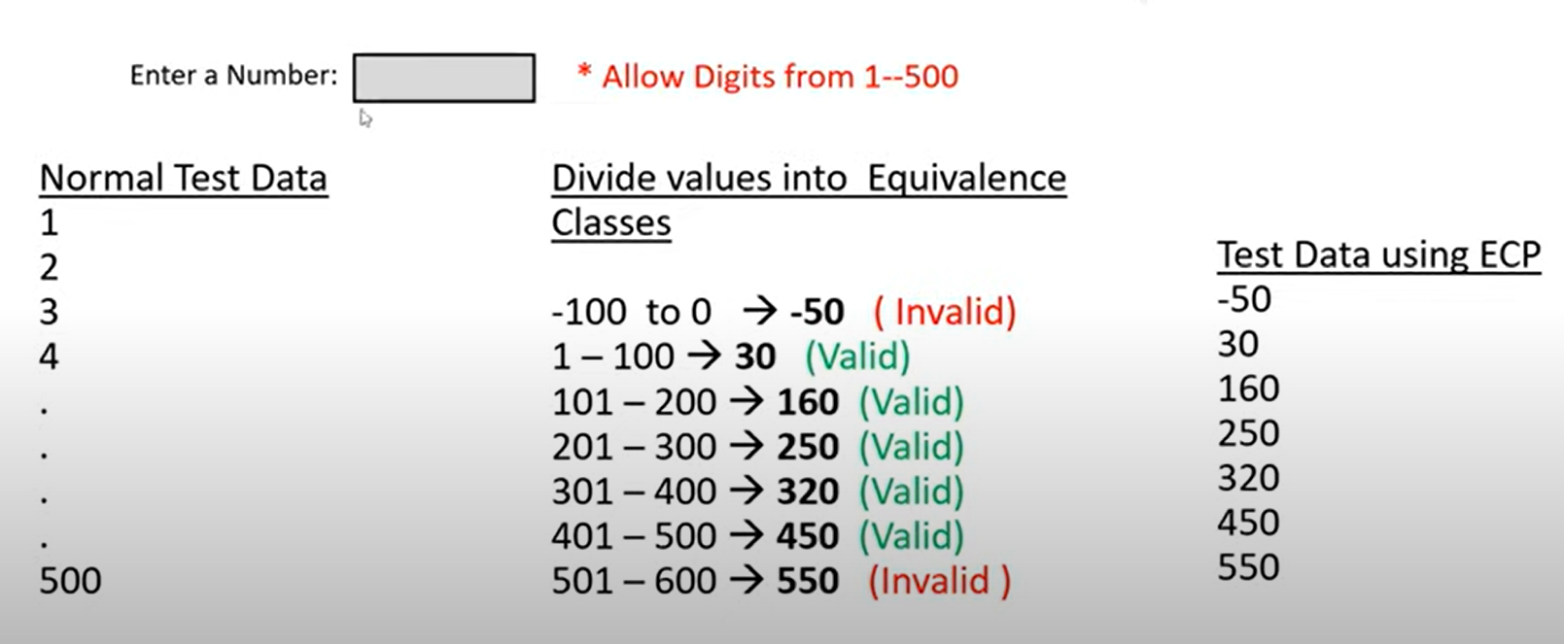

**2.Boundary Value Analysis (BVA)**

BVA technique used to check Boundaries of the input.

Min

Min+1

Min-1

Max

Max+1

Max-1

Example :

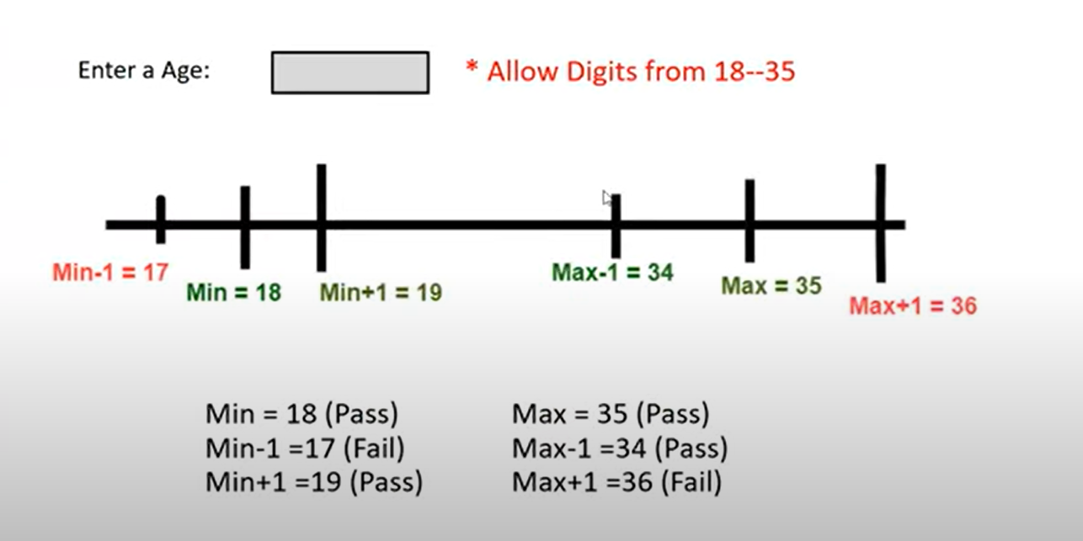

**3. Decision Table based testing**.

Decision Table is also called as Cause-Effect Table.

This technique will be used if we have more conditions and corresponding actions.

In Decision table technique, we deal with combinations of inputs.

To identify the test cases with decision table, we consider conditions and actions.

**Take an example of transferring money online to an account which is already added and approved.

Here the conditions to transfer money are

Account already approved

OTP (one time password) matched

Sufficient money in the account

And the actions performed are

Transfer money

Show a message as insufficient amount

Block the transaction incase of suspicious transaction

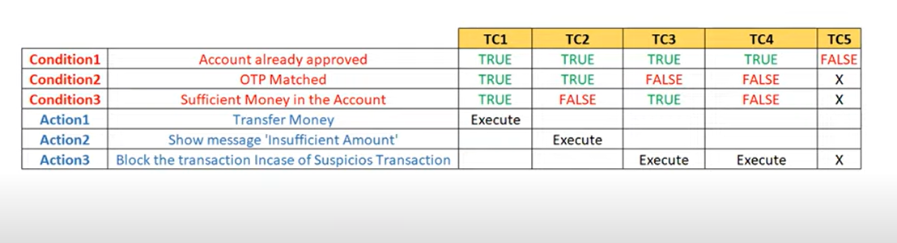

**4.State Transition**

In State Transition technique changes in input conditions change the state of the Application.

This testing technique allows the tester to test the behavior of an AUT.

The tester can perform this action by entering various input conditions in a sequence.

In State transition technique, the testing team provides positive as well as negative input test values for evaluating the system behavior.

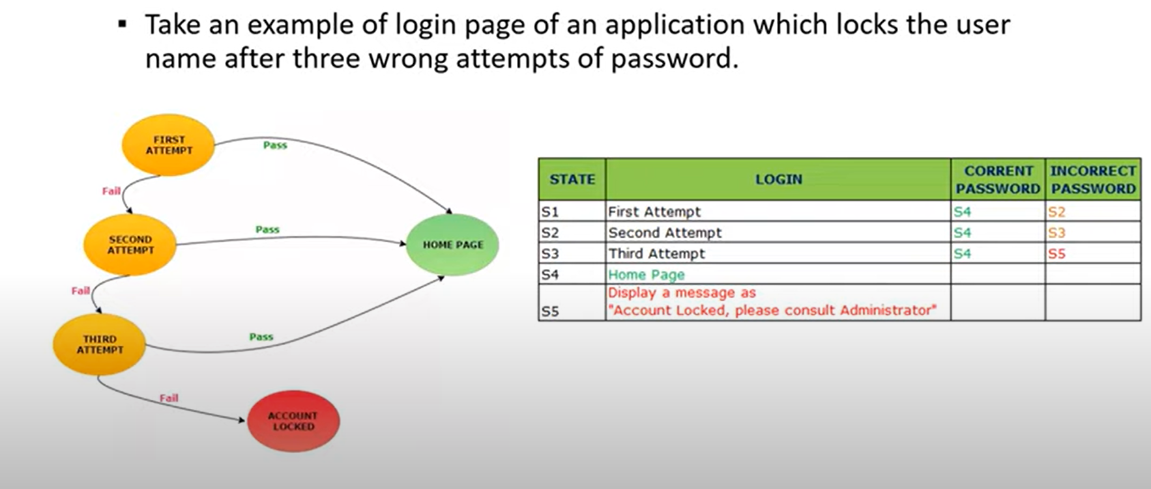

**5. Error Guessing**

Error guessing is one of the testing techniques used to find bugs in a software application based on tester's prior experience.

In Error guessing we don't follow any specific rules.

It depends on Tester Analytical skills and experience.

Some of the examples are:

Submitting a form without entering values.

Entering invalid values such as entering alphabets in the numeric field